|  |  |  |  |  |  |
| --- | --- | --- | --- | --- | --- |
| Date | 12-Dec-22 | | | Tester Name | Andrew McLaughlin |
| Environment | Penfax - Test | | | Login used |  |
| Operating System | Windows | Version: | Update: | | |
| Software Used | Edge | Version: | Update: | | |
| Select Software | Version: | Update: | | |
| Release version | 22.4.1 | | | | |
| Title | E5.23 Terminate someone under the age of 55 with province of employment Ontario | | | | |
| Test Type | Regression | | | | |
| Test Scenario | E5.23 Terminate someone under the age of 55 with province of employment Ontario | | | | |
|  |  | | | | |
| Expected Results | Employment should be ended with the End Reason Termination.  Member Status should be Deferred.  Termination Option Letter should be available in Penfax and Member PLANet. | | | | |
| Pass/Fail | Pass | | | JIRA# | N/A |

Describe your steps with screenshots:

1. Bring up active member who is under age 55. 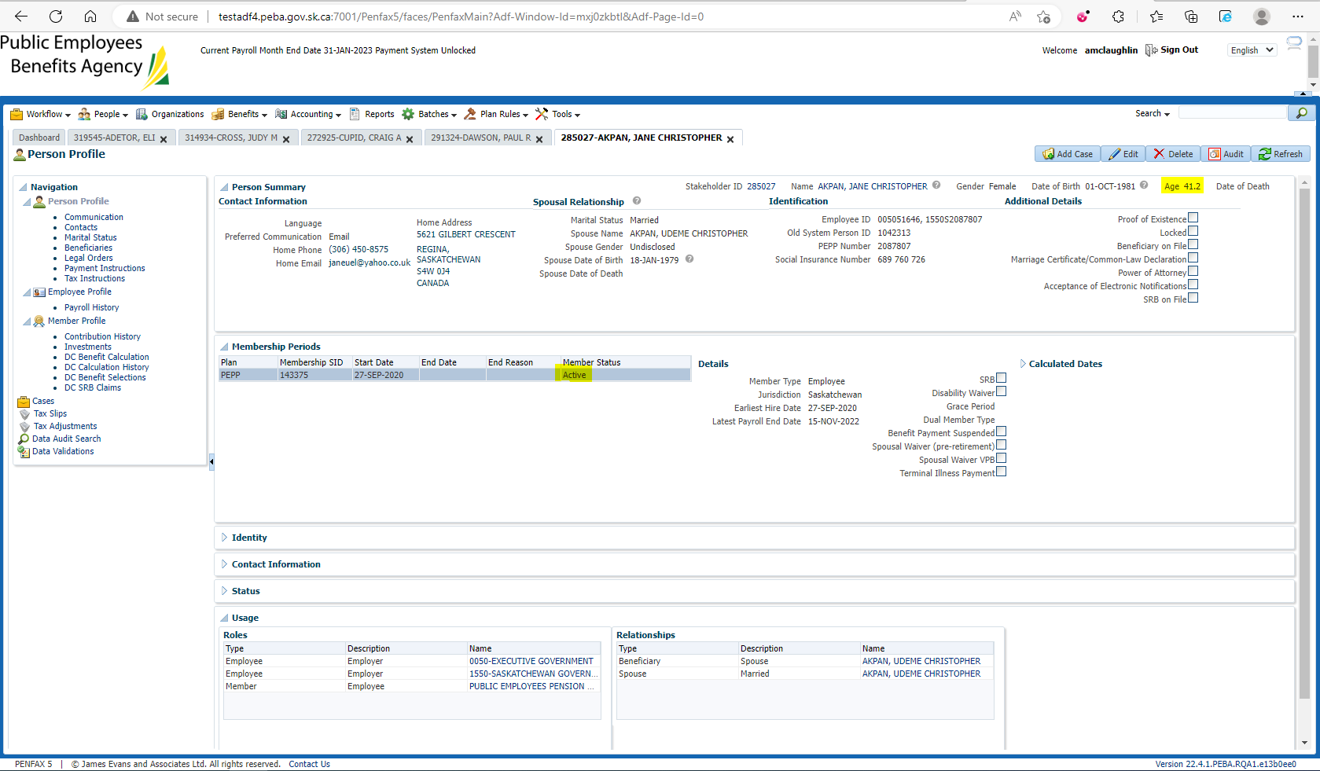
2. Log into DCT. Select an Employer from the dropdown and click on Import Data. Upload a CSV file for Termination. Validate, approve and process the file.
3. Go to Penfax and then Data Posting Batches. Click on Data Posting Batch ID, go to Pending tab and validate and then submit the transaction records.

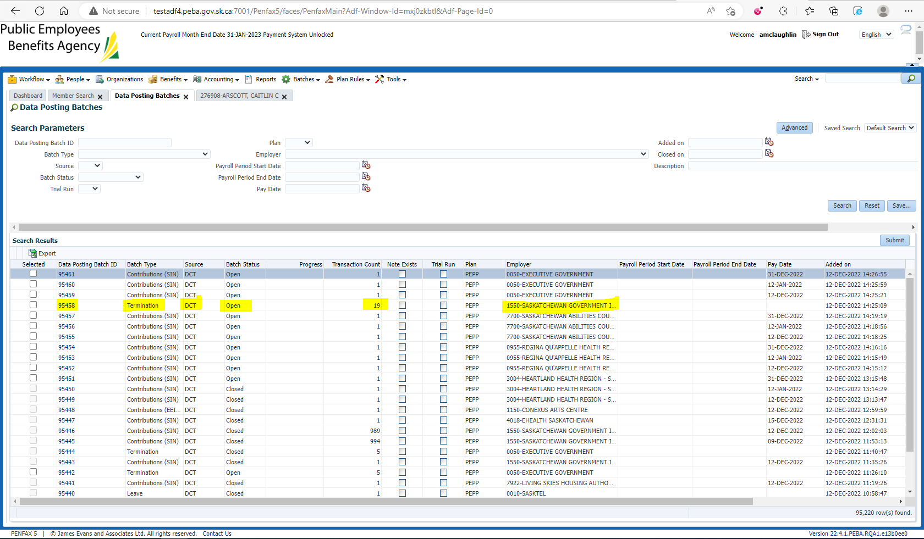

1. Once the data posting batch is submitted, bring up your member.
2. Go to Employee Profile -> Employment Periods, employment should now have the End Date and Termination as the End Reason. 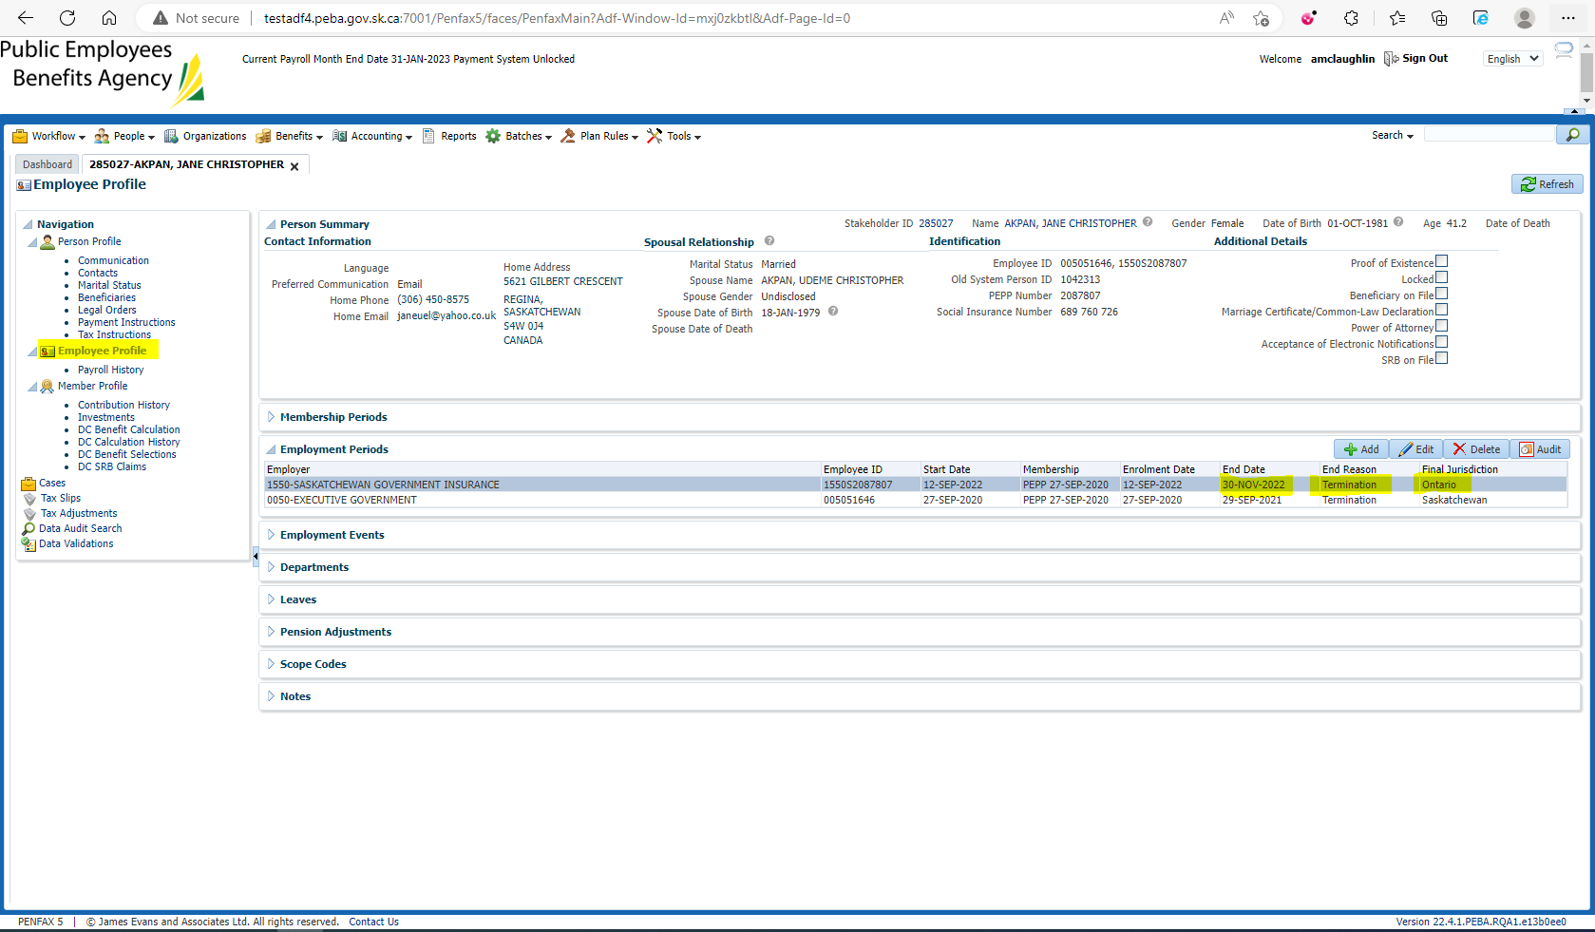
3. Go to Member Profile. Member Status should now be the Deferred. 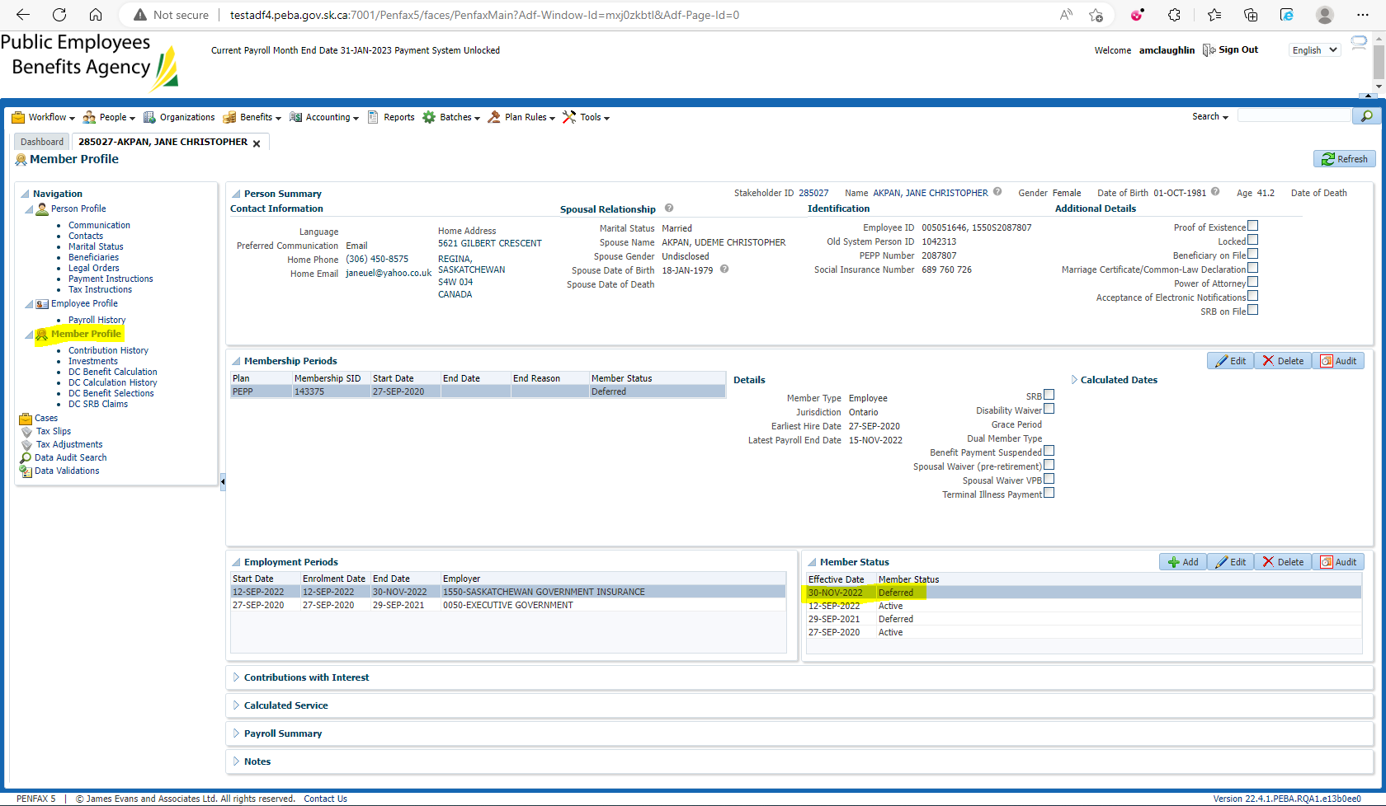
4. Go to Communication -> Outbound Documents -> Termination Option Letter should have been generated. 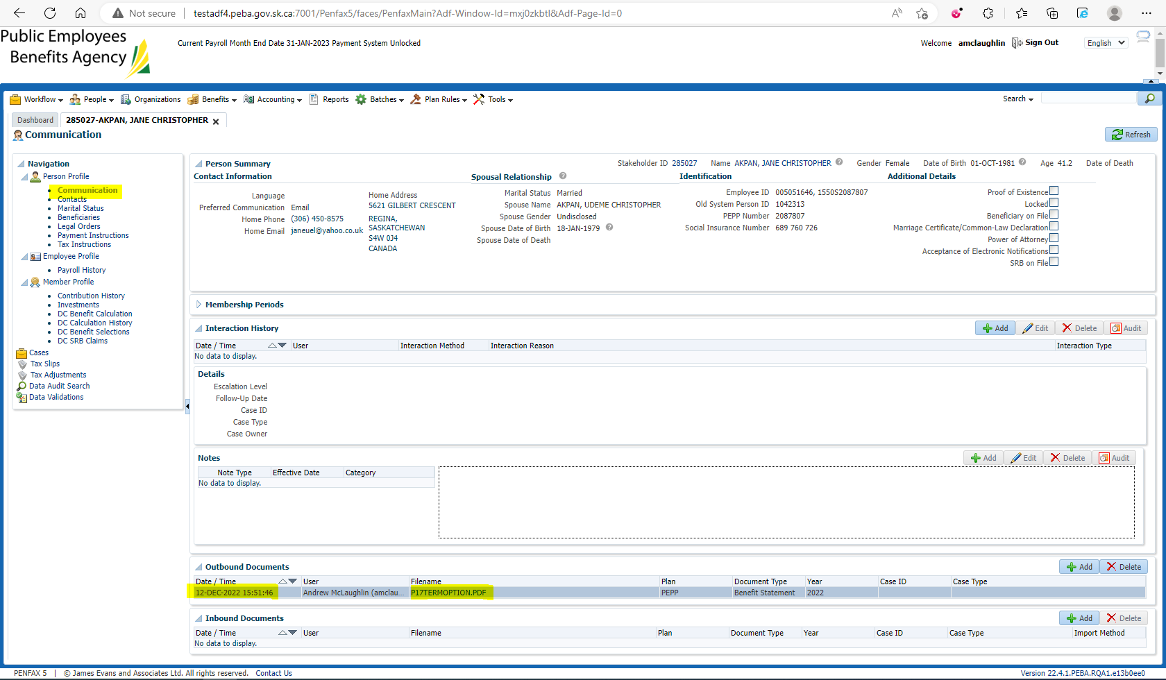
5. Letter PDF 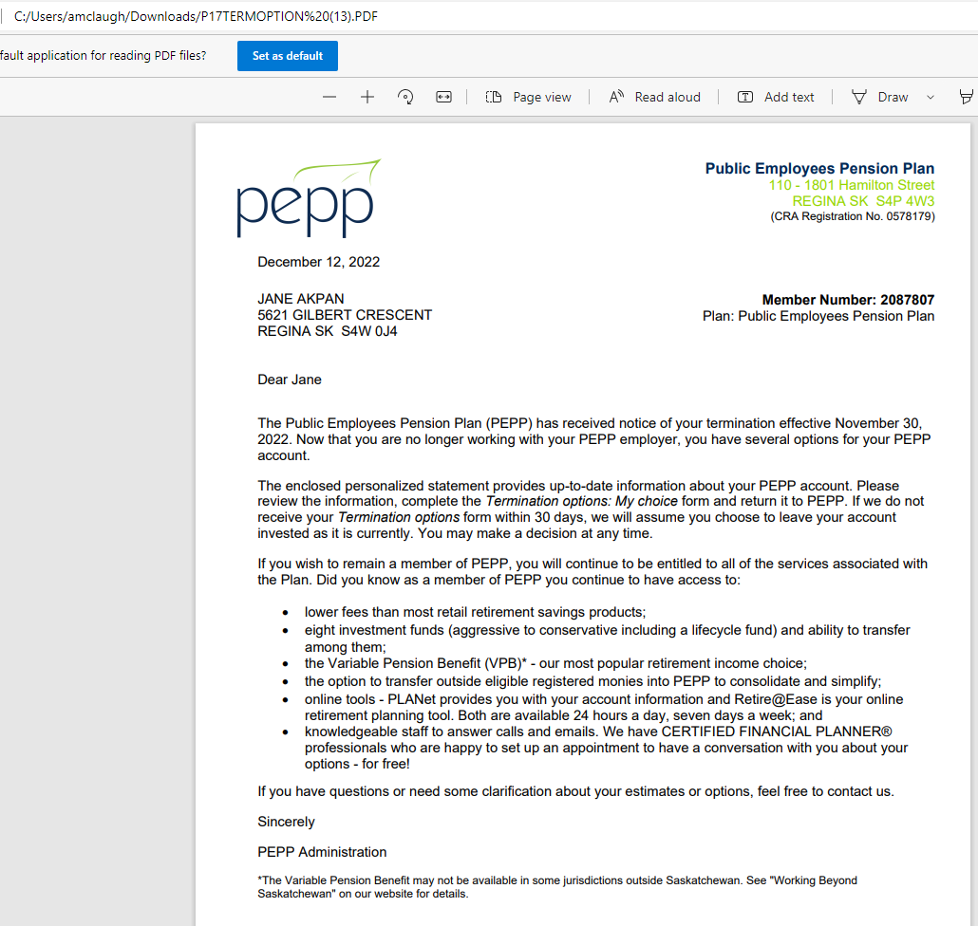
6. Termination Option Letter should be available in Member PLANet. 